# Test Document for Select Service Client

|  |  |  |  |
| --- | --- | --- | --- |
| Function Tested | Description | Test Output | Test Result |
| Display List of Artists | Drop down list that contains all the artists names | Figure 1 | Passed |
| Display List of Venues | Drop down list that contains all the venue names | Figure 2 | Passed |
| Display List of Shows | Drop down list that contains all the show names | Figure 3 | Passed |
| Shows per Artist Button | After selecting an artist from the dropdown the user clicks on this button to see all the shows | Figure 4 | Passed |
| Shows per Venue Button | After selecting a venue from the dropdown the user clicks on this button to see all the shows | Figure 5 | Passed |

Figure 1. Display List of Artists

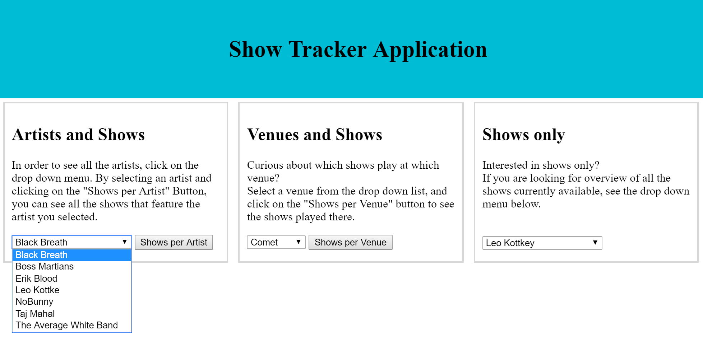

Figure 2. Display list of Venues

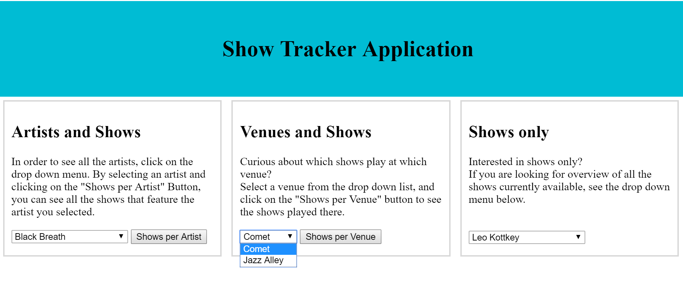

Figure 3. Display List of Shows

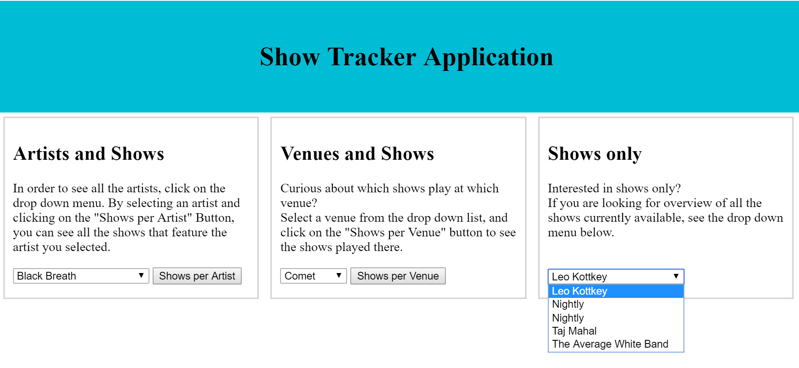

Figure 4. Shows per Artist Button

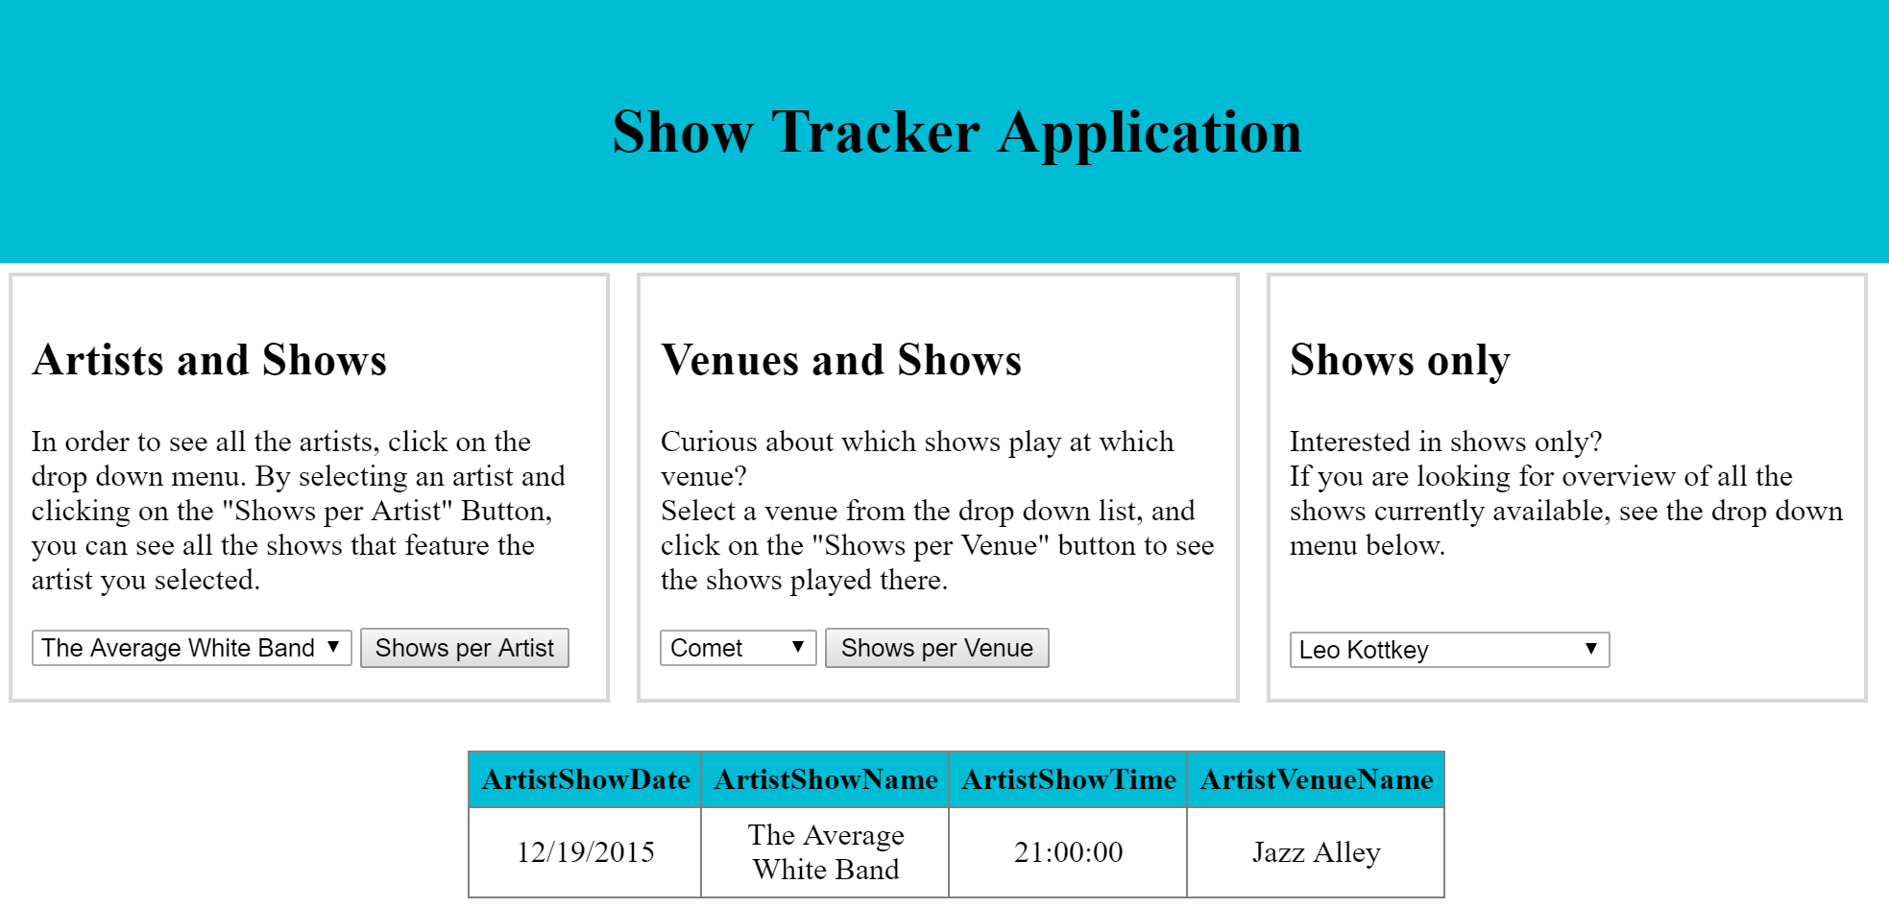

Figure 5. Shows per Venue Button

